15CSE334
Big Data Analytics
CASE-STUDY

Solar Data Analysis

Pandu Ranga Reddy (15CSE15422)
Arvind Sai (15CSE15302)
K Sai Chaitanya (15CSE15321)
Table of Contents
Sno | Title | page no
1 | Problem Statement | 3
2 | Abstract | 3
3 | Introduction | 4
4 | Motivation | 5
5 | About Dataset | 6
6 | Tool description | 8
7 | Data Analysis Questions & Implementation | 10
8 | Visualization | 21
9 | Summary | 25

Problem Statement
To analysis various types of data concerning solar power plant and the factors which affects them. Through Big Data Procedures this is made possible to breakdown the causes of uproar in the services of solar power plant and also reveal some thought-provoking actualities.

Abstract

The solar industry has grown considerably in the last few years. This larger scale has introduced more problems as well as possibilities. One of those possibilities is examining the data coming from the sites that are now being monitored, and using the information to answer a diverse of questions which promotes the use of renewable energy sources mainly solar energy. Since the data output is massive, we need to use the Big Data Practices to enhance and embraces the data in order to do that Mongo DB is the right choice and for illustration Microsoft Excel is a flawless tool.

Keywords – Bigdata, Mongo DB, Visualization, Microsoft Excel

Introduction

Like most sectors, the solar industry is rapidly embracing ways to analyze and crunch data in order to lower the cost of solar energy and to open up new markets for their technology.
The rise of data tools—algorithms, machine learning, sensors—are driving investments in, and acquisitions of, solar startups, while entrepreneurs are launching new companies that are using data to solve various solar industry problems. Meanwhile, big companies are spending money on tracking, monitoring and evaluating data from solar projects worldwide, helping to lower the cost of generating energy from the sun.
It shouldn’t come as a surprise that the solar sector is the latest to embrace the value of data. Other traditionally non-digital sectors, like the auto industry, oil and gas, and agriculture are turning to managing data as a necessity to keep their technology competitive and their companies in business.
But when it comes to the solar industry, it could end up being data that ultimately pushes down the cost of solar enough so that it can compete with fossil fuel energy. In that way, it’s not just a way for solar companies to make money but it would also be a way to transition the world from generating energy that emits tons of planet-warming carbon emissions.

Motivation

Most countries around the world have high ambitions in terms of deployment and integration of renewable energy generation capacities. Such a rapid increase in renewable energy penetration comes with technical, economical and regulatory challenges. Power systems and electricity markets were originally designed for conventional (say, thermal, nuclear and hydro-based) and centralized power generation, while near-future systems are set to rely on distributed and non-dispatchable generation as triggered by the deployment of renewable power generation capacities. these produce energy with nearly-Zero marginal cost according to nature’s will, the the inherent characteristics of being highly variable and of limited predictability. This introduces substantial challenges in the operation of power systems and electricity markets and also execution of Data Analysis is also hard since it produces a huge chunk of data every second which is the matter in early 20’s. Since the advent of technology and rapid upgradation of hardware market the resource of computing and analyzing the data produced by the renewable energy source is quite cheap. Hence our motivation is to investigate the huge volume of data which helps us to increase the efficiency and safeguarding the future.

About Data Set
The Desert Knowledge Australia Solar Centre (DKASC) is a demonstration facility for commercialized solar technologies operating in the arid solar conditions of Alice Springs, Central Australia. A standard and automated metering system has established the performance data from the DKASC as an invaluable source of long-term system level data. This information is collected at a resolution that confirms the reliability of solar technologies and logs power quality information that is relevant to the growth of large solar power stations in Australia. The system data is available for download from the Historical Data page of the website. It is contributing to the development of solar technologies in Australia and worldwide.
Data Set Name - First Solar, 7.0kW, CdTe, Fixed, 2008
Data Set Link - http://dkasolarcentre.com.au/historical-data/download
Organization - Solar Centre Desert Knowledge, Australia
No. of. Rows - 10,47,797
No. of. Column - 11
Location 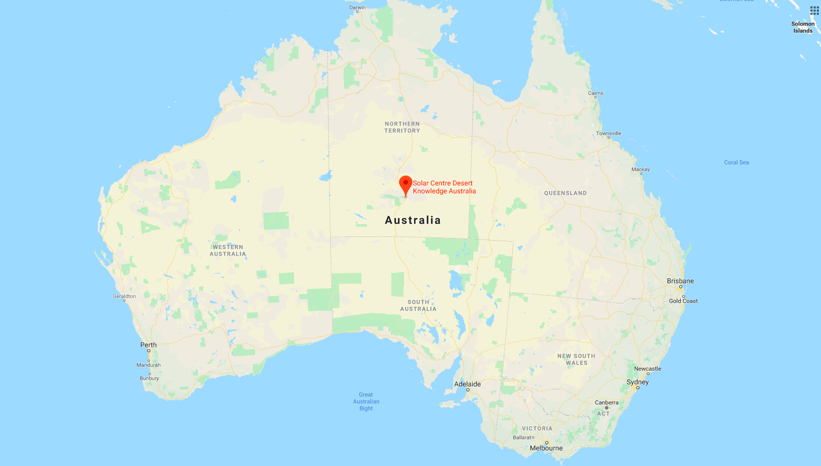

Fields in Data-Set:-
- Timestamp
- Active Energy Delivered-Received (kWh)
- Current Phase Average (A)
- Active Power (kW)
- Wind Speed (m/s)
- Weather Temperature Celsius (°C)
- Weather Relative Humidity (%)
- Global Horizontal Radiation (W/mÂ²)
- Diffuse Horizontal Radiation (W/mÂ²)
- Wind Direction (Degrees)
- Weather Daily Rainfall (mm)

Sample of Data-Set:-
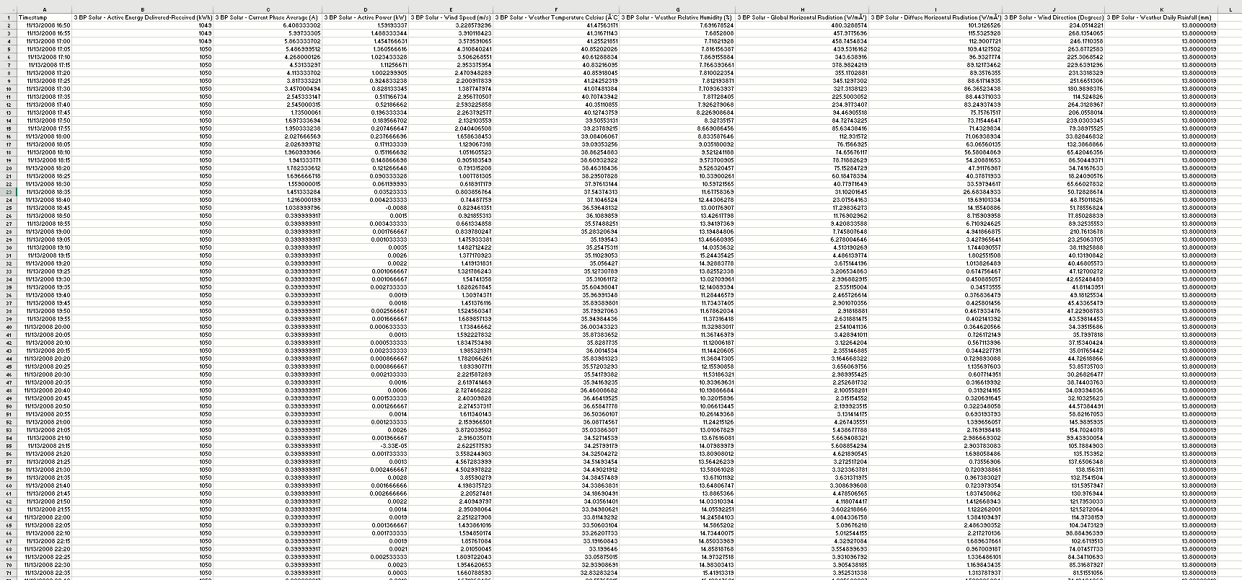

Tool Description

- Why NoSQL?
NoSQL is an approach to database design that can accommodate a wide variety of data models, including key-value, document, columnar and graph formats. NoSQL, which stand for "not only SQL," is an alternative to traditional relational databases in which data is placed in tables and data schema is carefully designed before the database is built. NoSQL databases are especially useful for working with large sets of distributed data.
- Why Mongo DB?
MongoDB is a cross-platform document-oriented database program. Classified as a NoSQL database program, MongoDB uses JSON-like documents with schemata. MongoDB is developed by MongoDB Inc. and licensed under the Server-Side Public License (SSPL).
Pros
- Document oriented
- High performance
- High availability — Replication
- High scalability – Sharding
- Dynamic — No rigid schema.
- Flexible – field addition/deletion have less or no impact on the application
- Heterogeneous Data
- No Joins
- Distributed
- Data Representation in JSON or BSON
- Geospatial support
- Easy Integration with Big Data Hadoop
- Document-based query language that’s nearly as powerful as SQL
- Cloud distributions such as AWS, Microsoft, RedHat, dotCloud and SoftLayer etc.: -. In fact, MongoDB is built for the cloud. Its native scale-out architecture, enabled by ‘sharding,’ aligns well with the horizontal scaling and agility afforded by cloud computing.
Cons
- A downside of NoSQL is that most solutions are not as strongly ACID-compliant (Atomic, Consistency, Isolation, Durability) as the more well-established RDBMS systems.
- Complex transaction

Good For:
- E-commerce product catalog.
- Blogs and content management.
- Real-time analytics and high-speed logging, caching, and high scalability.
- Configuration management.
- Maintaining location-based data — Geospatial data.
- Mobile and social networking sites.
- Evolving data requirements.
- Loosely coupled objectives — the design may change by over time.

Not so Good For:
- Highly transactional systems or where the data model is designed up front.
- Tightly coupled systems

- Symbol

MongoDB - 
NoSQL- 

Data Analysis
- what are the total number of records?
- what is the count of total number of days when active energy delivered was 1049?
- grouping energy and finding count in ascending order.
- highest weather temperature celsius recorded at what date and time?
- what is the max current phase average when the active energy delivered was 1049?
- At what temperature the weather relative humidity recorded was least?
- what is the average wind speed corresponding to active energy delivered?
- what are the global horizontal radiation and diffuse horizontal radiation when wind direction is greater than 250 degrees?
- what is the amount of rainfall happened and the timestamp when the temperature is less than 25 celsius and humidity is greater than 75?
- display the top third and fourth records on basis of wind speed and active power?
- using mapreduce programming find the max humidity for given active energy delivered?
- what is the active energy delivered when active power is least?
- what is the count of total records per day in the dataset sorted by day count?
- what is the maximum temperature recorded on a particular day?
- what is the maximum humidity recorded on a particular day?
- what is the active power when global horizontal radiation and diffuse horizontal radiation are maximum?
- On a particular day what is the max active power?
- what is the total active energy delivered on a particular day?
- what is the least current phase average when the rain fall happened was least?
- what is the total current phase average generated per day?

Implementation and Results

Queries:(All in MongoDB)

- what are the total number of records?

db.solar.count(); // Query
output:
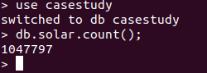

- what is the count of total number of days when active energy delivered was 1049?

> var myc = db.solar.find({Active_Energy_Delivered:1049});
> print("The count is:"+myc.count());
output: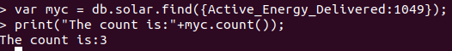
- grouping energy and finding count in ascending order.

db.solar.aggregate({$group:{_id:"$Active_Energy_Delivered",count:{$sum:1}}},{$sort:{_id:1}});
output:
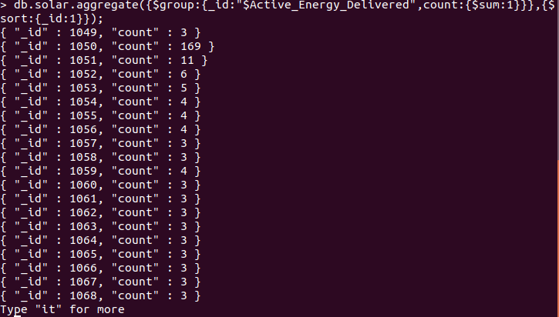

- highest weather temperature celsius recorded at what date and time?
db.solar.find({},{Timestamp:1,Weather_Temperature_Celsius:1,_id:0}).sort({Weather_Temperature_Celsius:-1}).limit(1);
output: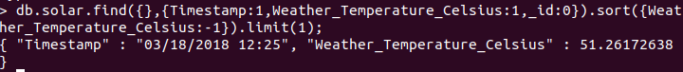

- what is the max current phase average when the active energy delivered was 1049?
db.solar.find({Active_Energy_Delivered:1049},{Current_Phase_Average:1,_id:0}).sort({Current_Phase_Average:-1}).limit(1);

output:

- At what temperature the weather relative humidity recorded was least?
db.solar.find({},{Weather_Temperature_Celsius:1,Weather_Relative_Humidity:1,_id:0}).sort({Weather_Relative_Humidity:1}).limit(1)

output:

- what is the average wind speed corresponding to active energy delivered?
db.solar.aggregate({$group:{_id:"$Active_Energy_Delivered",Wind_Speed_Average:{$avg:"$Wind_Speed"}}},{$sort:{_id:1}});
output:
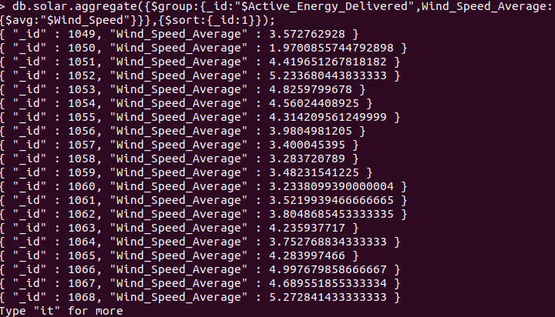

- what are the global horizontal radiation and diffuse horizontal radiation when wind direction is greater than 250 degrees?
db.solar.find({Wind_Direction:{$gt:250}},{Wind_Direction:1,Global_Horizontal_Radiation:1,Diffuse_Horizontal_Radiation:1,_id:0}).pretty();
output:
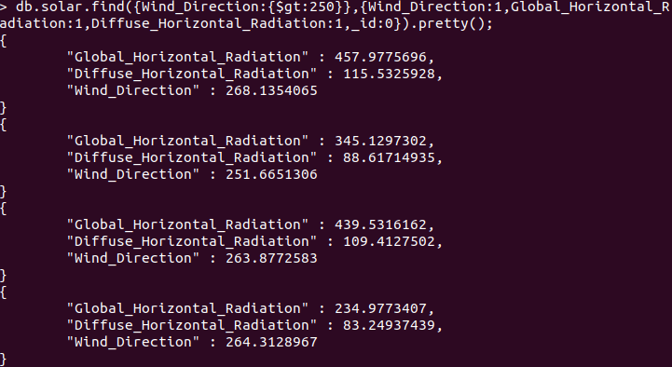

- what is the amount of rainfall happened and the timestamp when the temperature is less than 25 celsius and humidity is greater than 75?

db.solar.find({Weather_Temperature_Celsius:{$lt:25},Weather_Relative_Humidity:{$gt:75}},{Timestamp:1,Weather_Daily_Rainfall:1,_id:0}).pretty();
output:
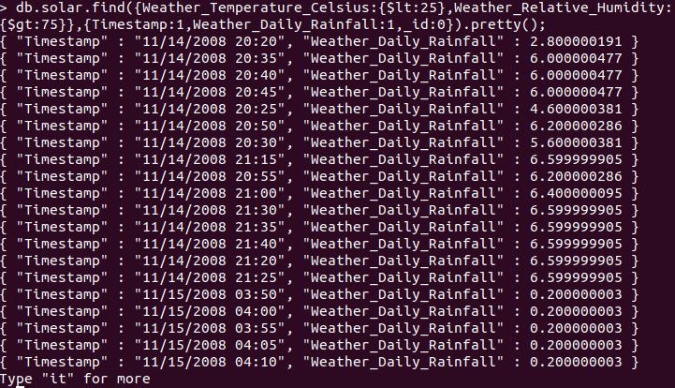

- display the top third and fourth records on basis of wind speed and active power?
db.solar.find().sort({Wind_Speed:-1,Active_Power:-1}).skip(2).
limit(2).pretty();
output:
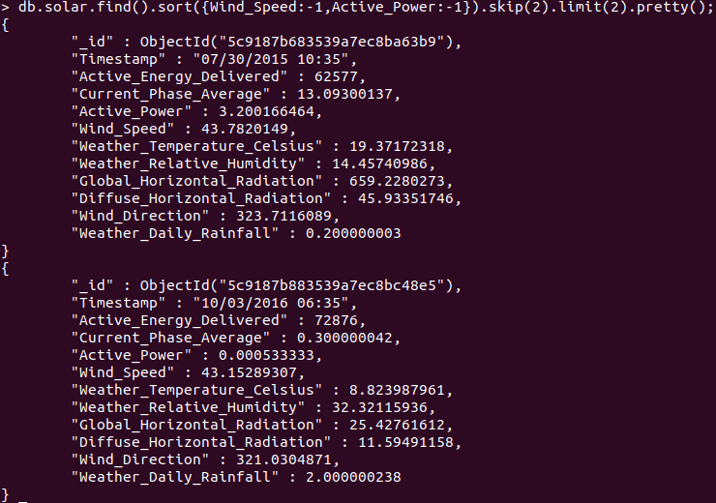

- using mapreduce programming find the max humidity for given active energy
delivered?
>var mapfunction = function(){emit(this.Active_Energy_Delivered,this.Weather_Relative_Humidity)};
>var reducefunction = function(key,value){var max=value[0]; value.forEach(function(val1){if (val1 > max) max = val1;}); return max;};
>db.solar.mapReduce(mapfunction,reducefunction,{out:"humid_solar"});

output:
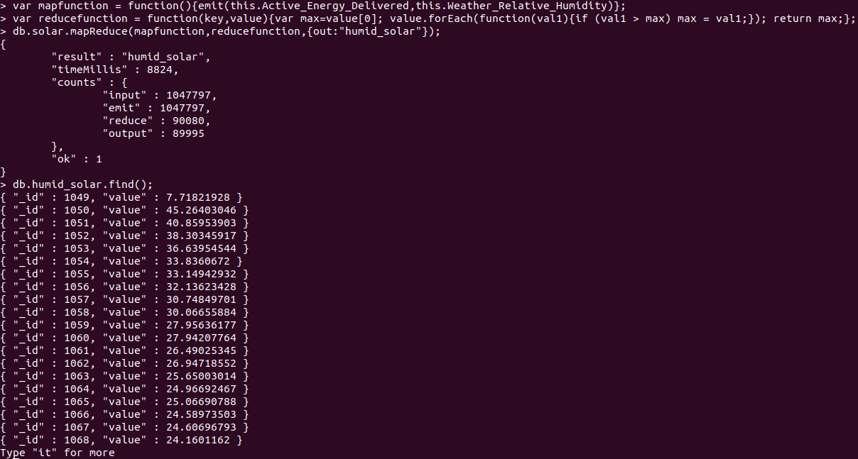

- what is the active energy delivered when active power is least?
db.solar.find({},{Active_Energy_Delivered:1,Active_Power:1,_id:0}).sort({Active_Power:1}).limit(1).pretty();
output:

- what is the count of total records per day in the dataset sorted by day count?
db.solar.aggregate({$project:{date:{$substr:["$Timestamp",0,10]},time:{$substr:["$Timestamp",11,-1]}}},{$group:{_id:"$date",count:{$sum:1}}},{$sort:{count:1}}).pretty();
output:
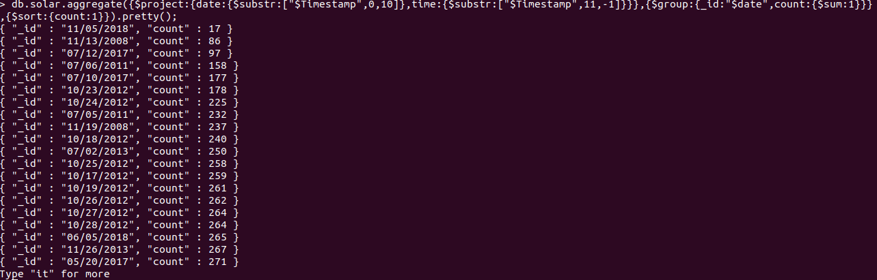
- what is the maximum temperature recorded on a particular day?

db.solar.aggregate({$project:{date:{$substr:["$Timestamp",0,10]},temp:"$Weather_Temperature_Celsius"}},{$group:{_id:"$date",temp_max:{$max:"$temp"}}}).pretty();

output: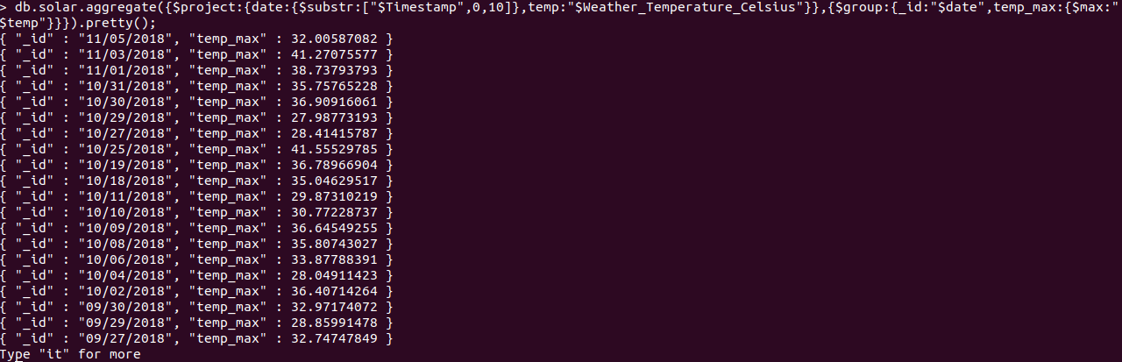

- what is the maximum humidity recorded on a particular day?
db.solar.aggregate({$project:{date:{$substr:["$Timestamp",0,10]},humid:"$Weather_Relative_Humidity"}},{$group:{_id:"$date",humid_max:{$max:"$humid"}}}).pretty();
output:
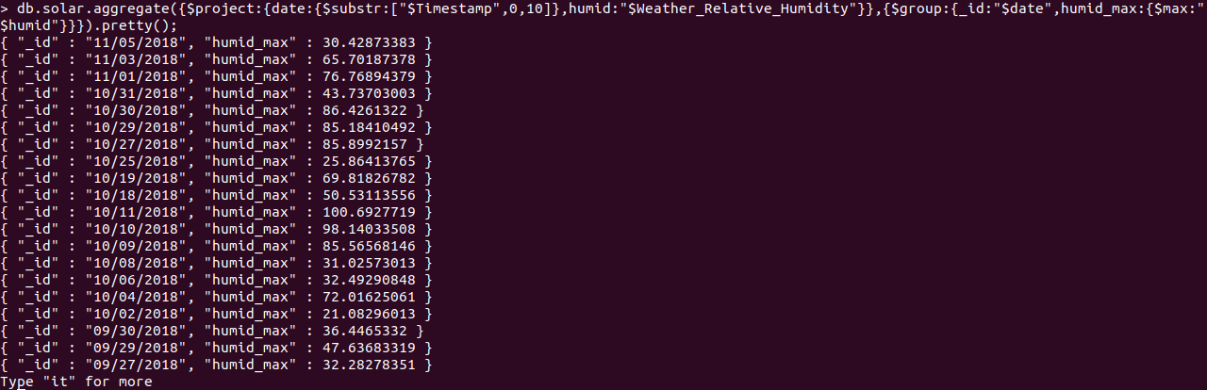

- what is the active power when global horizontal radiation and diffuse horizontal radiation are maximum?
db.solar.find({},{Active_Power:1,Global_Horizontal_Radiation:1,Diffuse_Horizontal_Radiation:1,_id:0}).sort({Global_Horizontal_Radiation:-1,Diffuse_Horizontal_Radiation:-1})
.limit(1).pretty();
output: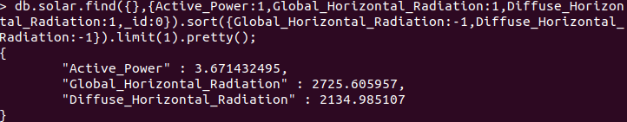
- On a particular day what is the max active power?
db.solar.aggregate({$project:{date:{$substr:["$Timestamp",0,10]},power:"$Active_Power"}},{$group:{_id:"$date",max_power:{$max:"$power"}}}).pretty();
output:
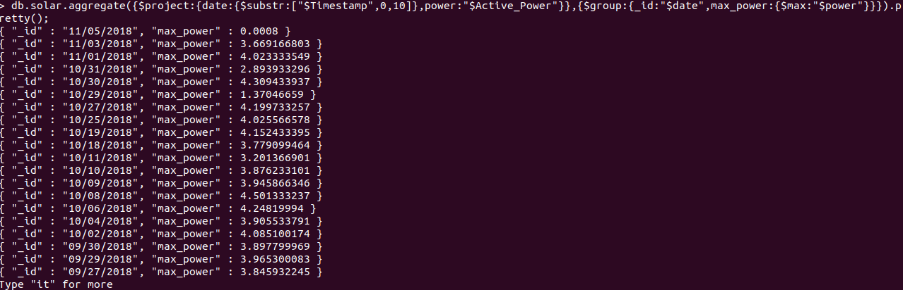
- what is the total active energy delivered on a particular day?
db.solar.aggregate({$project:{date:{$substr:["$Timestamp",0,10]},energy:"$Active_Energy_Delivered"}},{$group:{_id:"$date",total_energy:{$sum:"$energy"}}}).pretty();
output: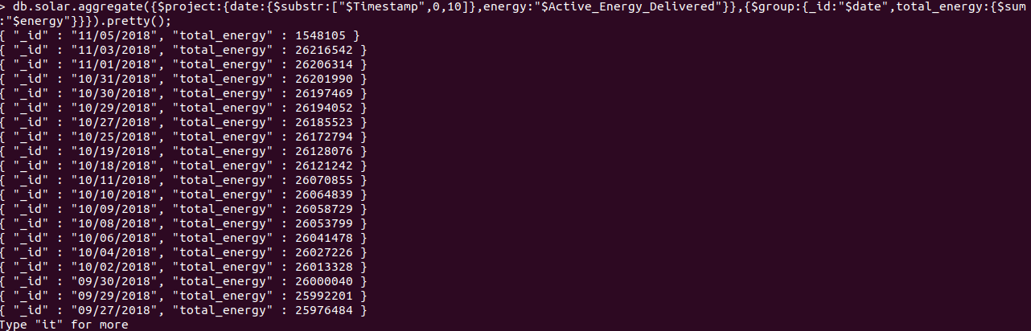
- what is the least current phase average when the rain fall happened was least?
db.solar.find({},{Current_Phase_Average:1,Weather_Daily_Rainfall:1,_id:0}).sort({Weather_Daily_Rainfall:1,Current_Phase_Average:1}).limit(1).pretty();
output:
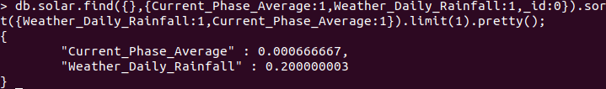
- what is the total current phase average generated per day?
db.solar.aggregate({$project:{date:{$substr:["$Timestamp",0,10]},current:"$Current_Phase_Average"}},{$group:{_id:"$date",total_current:{$sum:"$current"}}}).pretty();
output:
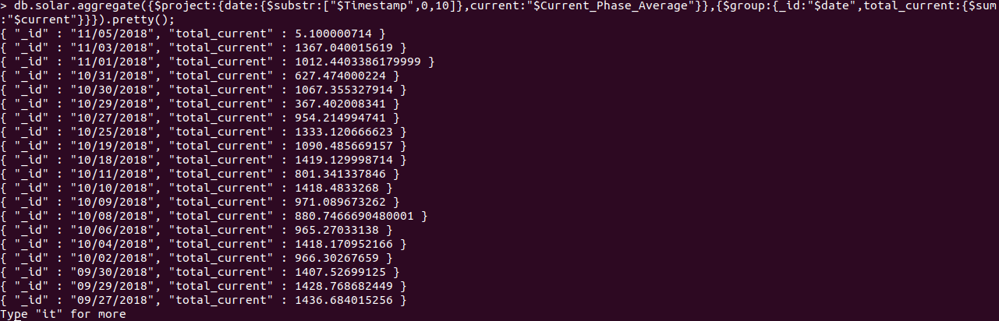

Visualization

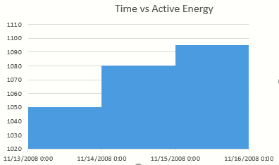
The Above fig illustrates the contrast between Time vs Active Energy Consumption in the period of time.

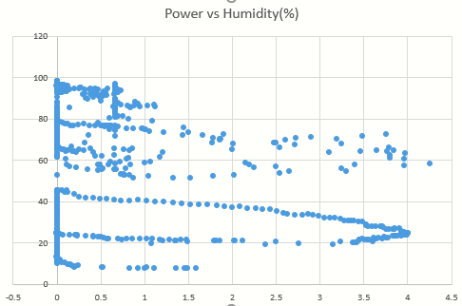
The Above fig illustrates the contrast between Power vs Humidity Stating that Power output decreases with increase in Humidity

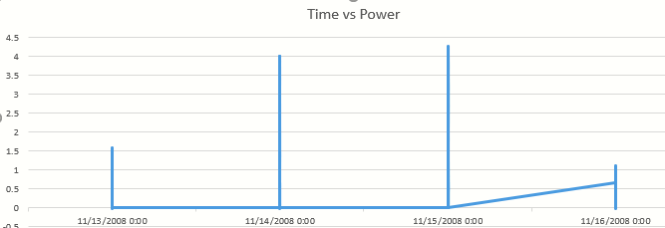

The Above fig illustrates the contrast between Time vs Power

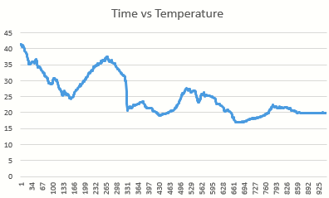
The Above fig illustrates the contrast between Time vs Temperature Where the X-Axis indicates the timestamp-id’s

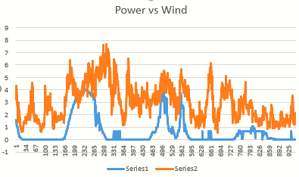
The Above fig illustrates the contrast between Power vs Wind Speed Stating that Power output increases with increase in Wind Speed

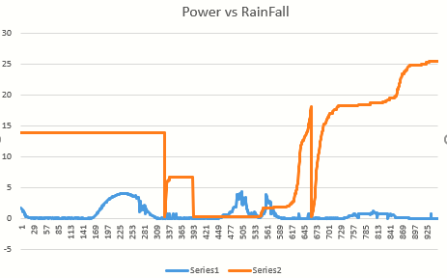

The Above fig illustrates the contrast between Power vs RainFall Stating that Power output Decreases with increase in Rainfall.

Summary of Data Analysis
These results indicate, that the power generation detailed in the data is affected by major factors like humidity, rainfall and wind speed.
In view of the multiple and diverse foreseen applications of the dataset, we consider it outside the scope of this manuscript to attempt a full evaluation of the dataset’s efficiency for various applications. Instead we foucued to identify caveats and limitations for their use case, to provide visualization in order for the people to evolve and understand the importance of renewable energy i.e., Solar Energy and the factors that affect them.
 | Wind Speed | Radiation | Humidity | Rainfall
Power | Proportional | Proportional | Inversely Proportional | Inversely Proportional

From the Analysis we can conclude that
Maximum temperature recorded: 51.26 C
Maximum Humidity recorded: 102.89
Maximum global horizontal radiation recorded: 2725.60
Maximum diffuse horizontal radiation: 2134.98
Maximum Rainfall recorded: 67.199
Maximum wind speed recorded:54.39
The active power is 3.67kW which was recorded when the radiation was high.

Thank You

